OTS3000-OBP

Smart Optical Bypass System


User’s Manual

All trademarks mentioned in this manual are registered property of our company.

The content of this manual is subject to our explanation.

 |  | CONTENTS
1. | DESCRIPTIONS............................................................................................................................. |  | 1
2. | FEATURES ..................................................................................................................................... |  | 1
3. TECHNICAL PARAMETERS .......................................................................................................... |  |  | 3
4. INSTRUCTIONS ................................................................................................................................. |  |  | 6
 | 4.1 | PANEL INSTRUCTIONS ......................................................................................................... | 6
 | 4.2 | EQUIPMENT CONNECTION INSTRUCTIONS .......................................................................... | 8
 | 4.3 | LCD INSTRUCTIONS ............................................................................................................ | 9
 | 4.4 | THE HOST COMPUTER MONITORING INSTRUCTIONS ............................................................ | 18
5. PRECAUTIONS AND MAINTENANCE ....................................................................................... |  |  | 26
 | 5.1 | PRECAUTIONS .................................................................................................................. | 26
 | 5.2 | EQUIPMENT MAINTENANCE ................................................................................................ | 26
6. TROUBLESHOOTING .................................................................................................................... |  |  | 26

1. Descriptions

OTS3000-BPS is a Smart Optical Bypass platform equipment which adopts the standard 19 inches chassis design. Its redundant power and pluggable design support dual AC, dual DC ,and AC&DC power supply mode. OBP is a kind of optical switch system which can bypass fault node in optical transmission network to avoid breakdown of whole network communication when there appear power interruption, hardware failure, software deadlock etc. It can automatically switch by detecting the node’s optical power or signal failure. OBP is mainly used to protect the flow control and RPT equipment.

- Features

  - With low insertion loss and fast switching speed.

  - With LCD displaying optical line status, which is much convenient for users.

  - Users can set the device address to control multiple optical switching devices with a serial port and RJ45 port.

  - Alarm function:

    - Sound Alarm: the device will alarm with the Buzzer on it and there is the sound banning functions.
② Light Alarm: the device’s alarm will be indicate by the LED and LCD screen.

  - Automatic Mode: the screen indicates “ Auto Mode”, then the device can switch from the primary to secondary path automatically.

When the external elements leading the primary and secondary switching, the device working mode will stay at “ Auto Mode” all the time; When the user switch the optical path through the panel buttons, the device will be forced to stay at “ Manual Mode”; When the user switch the optical path by the remote management commands, the device will come

into “Auto Mode” or “Manual Mode” according to the different commands.

- Manual Mode:

  - The screen indicates “Manual Mode” , then users can manually switch the primary

and the secondary path randomly by panel buttons or commands, the device will stay at the same path without any changes.

  - Manual mode returns to automatic mode function: when the equipment is under the “manual mode” and without any key pressing operation, the equipment will automatically return to “ auto mode”, under the condition that the user set “manual back to auto mode delay”(1-999 minutes, default time be 30 minutes) previously. To set 000 minutes means automatically return function is prohibited.

- Setting Cut back way function:

1/27

- “ Auto back”: under the automatic mode, when it meet the primary path condition ,while the status be the secondary path online, the equipment will automatically back to the primary path after the automatic back delay (0-9999 second).
② “ Manual back”: whether under the automatic mode or the manual mode, the

equipment automatically switch from primary to secondary path, users have to switch the path to primary by panel buttons or commands.

(8) Setting Active send the heartbeat packets of ICMP function:

- Under the mode of “Auto mode and Auto no back”, the screen indicates “ Auto mode” with the device active signal function on, the optical path will automatically switch to “Primary” when the device receive the ICMP responding packet with the current path at “Bypass” after the automatically cut-back time relaying (0~9999 second); while the device receive the ICMP responding packet with continuous 65536 pieces packet loss, the optical path will immediately

switch to “ Bypass”.

- Under the mode of “Auto mode and Auto no back”, the screen indicates “Auto mode” with the device active signal function on, the optical path wont automatically switch to “Primary” when the device receive the ICMP responding packet with the current path at “Bypass”, users have to switch the path to primary state through the buttons or commands. while the device receive the ICMP responding packet with continuous 65536 pieces packet loss, the optical path will immediately switch to “ Bypass”.

(9) Passive signal packet setting:

① Under the mode of “Auto mode and Auto back”, the screen indicates “Auto mode” with the device passive signal function on, the optical path will automatically switch to “Primary” when the device receive the signal packet with the current path at “Bypass” after the automatically cut-back time relaying (0~9999 second); while the device receive continuous 65536 pieces packet loss, the optical path will immediately switch to “ Bypass”.

- Under the mode of “Auto mode and Auto no back”, the screen indicates “Auto mode”

with the device passive signal function on, the optical path wont automatically switch to “Primary” when the device receive the ICMP responding packet with the current path at “Bypass”, users have to switch the path to primary state through the buttons or commands. while the device receive continuous 65536 pieces packet loss, the optical path will immediately switch to “Bypass”.

- Booting time relaying function setting: the device will work on after the booting time replaying (0-9999 second). This function is mainly used to fit the protected device booting time in case that the device switch to the “Primary”, thus leading to the network interruptions.
- Bypass without optical signal setting:

- Under the mode of “Auto mode and Auto back”, the screen indicates “Auto mode”, when the receiving optical power meet the bypass without optical signal conditions as R1 without optical signal, R2 without optical signal, R1/R2 anyone of them without optical signal or R1/R2 both without optical signal, the optical path will immediately switch to “Bypass”. When

2/27

the receiving optical power does not meet the bypass without optical signal conditions, the optical path will automatically switch to the “Primary”.

  - Monitoring function setting: the device with the RJ45 port on it.

- Technical Parameters

Parameters | Unit | OTS3000-1U
Chassis Slot |  | 2 power slot ，1 NUM slot，
Chassis Slot |  | 1 fan slot， 4 function slot
Dimension | mm | 482.6×300×44（WxDxH）
Maximal Device Power | W | 50 or 100
Device Weight | Kg | 6
Power Supply |  | Redundant power: DC 36V~72V or AC 100V~240V
Fan Type |  | Plug-in
Operating Temperature | ℃ | -5 ~ +55
Storage Temperature | ℃ | -20~+70
Relative Humidity |  | 5% ~ 95% (non-condensing)

Parameters | Unit | OTS3000-2U
Chassis Slot |  | 2 power slot ，1 NUM slot，
Chassis Slot |  | 1 fan slot， 8 function slot
Dimension | mm | 482.6×300×89（WxDxH）
Maximal Device Power | W | 100 or 160
Device Weight | Kg | 8
Power Supply |  | Redundant power: DC 36V~72V or AC 100V~240V
Fan Type |  | Plug-in
Operating Temperature | ℃ | -5 ~ +55
Storage Temperature | ℃ | -20~+70
Relative Humidity |  | 5% ~ 95% (non-condensing)

Parameters | Unit | OTS3000-4U
Chassis Slot |  | 2 power slot ，1 NUM slot，
Chassis Slot |  | 1 fan slot， 16 function slot
Dimension | mm | 482.6×300×178（WxDxH）
Maximal Device Power | W | 160 or 300
Device Weight | Kg | 12
Power Supply |  | Redundant power: DC 36V~72V or AC 100V~240V
Fan Type |  | Plug-in
Operating Temperature | ℃ | -5 ~ +55
Storage Temperature | ℃ | -20~+70
Relative Humidity |  | 5% ~ 95% (non-condensing)

3/27

Parameters |  |  |  | Unit |  |  | OTS3000-OBP
Dimension |  |  |  | mm |  |  | 160×200×21（WxDxH）
Maximal Power |  |  |  | W |  |  | 1 W (single link), 2W (dual link)
Consumption |  |  |  | W
Protection Ways |  |  |  |  | SM 1:1 |  | SM 1+1 |  | MM 1:1 |  | MM 1+1
 |  | R3–T1 |  |  | ≤ 1.5 |  | ≤ 3.8 |  | ≤ 1.5 |  | ≤ 3.8
 |  | R4–T2 |  |  | ≤ 1.5 |  | ≤ 3.8 |  | ≤ 1.5 |  | ≤ 3.8
Insertion |  | R1–T3 |  | dB | ≤ 1.5 |  | ≤ 1.5 |  | ≤ 1.5 |  | ≤ 1.5
Loss |  | R2–T4 |  | dB | ≤ 1.5 |  | ≤ 1.5 |  | ≤ 1.5 |  | ≤ 1.5
 |  | R3–T4 |  |  | ≤ 1.5 |  | ≤ 5.0 |  | ≤ 1.5 |  | ≤ 5.0
 |  | R4–T3 |  |  | ≤ 1.5 |  | ≤ 5.0 |  | ≤ 1.5 |  | ≤ 5.0
Protection Ways |  |  |  |  | SM 1:1M |  | SM 1+1M |  | MM 1:1M |  | MM 1+1M
 |  | R3–T1 |  |  | ≤ 1.5 |  | ≤ 3.8 |  | ≤ 1.5 |  | ≤ 3.8
 |  | R4–T2 |  |  | ≤ 1.5 |  | ≤ 3.8 |  | ≤ 1.5 |  | ≤ 3.8
 |  | R1 | – T3/M50 |  | ≤ 5.0/5.0 |  | ≤ 5.0/5.0 |  | ≤ 5.0/5.0 |  | ≤ 5.0/5.0
 |  | R2 | – T4/M50 |  | ≤ 5.0/5.0 |  | ≤ 5.0/5.0 |  | ≤ 5.0/5.0 |  | ≤ 5.0/5.0
 |  | R3 | – T4/M50 |  | ≤ 5.0/5.0 |  | ≤ 8.5/8.5 |  | ≤ 5.0/5.0 |  | ≤ 8.5/8.5
 |  | R4 | – T3/M50 |  | ≤ 5.0/5.0 |  | ≤ 8.5/8.5 |  | ≤ 5.0/5.0 |  | ≤ 8.5/8.5
Insertion |  | R1 – T3/M40 |  | dB | ≤ 4.0/6.0 |  | ≤ 4.0/6.0 |  | ≤ 4.0/6.0 |  | ≤ 4.0/6.0
Loss |  | R2 – T4/M40 |  | dB | ≤ 4.0/6.0 |  | ≤ 4.0/6.0 |  | ≤ 4.0/6.0 |  | ≤ 4.0/6.0
 |  | R3 | – T4/M40 |  | ≤ 4.0/6.0 |  | ≤ 7.5/9.5 |  | ≤ 4.0/6.0 |  | ≤ 7.5/9.5
 |  | R4 | – T3/M40 |  | ≤ 4.0/6.0 |  | ≤ 7.5/9.5 |  | ≤ 4.0/6.0 |  | ≤ 7.5/9.5
 |  | R1 | – T3/M30 |  | ≤ 3.3/7.2 |  | ≤ 3.3/7.2 |  | ≤ 3.3/7.2 |  | ≤ 3.3/7.2
 |  | R2 | – T4/M30 |  | ≤ 3.3/7.2 |  | ≤ 3.3/7.2 |  | ≤ 3.3/7.2 |  | ≤ 3.3/7.2
 |  | R3 | – T4/M30 |  | ≤ 3.3/7.2 |  | ≤6.8/10.7 |  | ≤ 3.3/7.2 |  | ≤6.8/10.7
 |  | R4 | – T3/M30 |  | ≤ 3.3/7.2 |  | ≤6.8/10.7 |  | ≤ 3.3/7.2 |  | ≤6.8/10.7
Return Loss |  |  |  | dB |  | ≥ 45 |  |  |  | ≥ 30
Crosstalk |  |  |  | dB |  | ≥ 55 |  |  |  | ≥ 35
 | PDL |  |  | dB |  | ≤ 0.2 |  |  |  | ≤ 0.2
 | WDL |  |  | dB |  | ≤ 0.3 |  |  |  | ≤ 0.3
Switching Time |  |  |  | ms |  | ＜ 8 |  |  |  | ＜ 8
Operating Temperature |  |  |  | ℃ |  |  |  | -5 ~ +55
Storage Temperature |  |  |  | ℃ |  | -20 ~ +70
Relative Humidity |  |  |  |  |  |  | 5% ~ 95% (non-condensing)

4/27

Parameters |  |  |  | Unit | OTS3000-OBP-BIDI
 | Dimension |  |  | mm | 160×200×21（WxDxH）
Maximal Power |  |  |  | W | 1 W (single link), 2W (dual link)
Consumption |  |  |  | W
Protection Ways |  |  |  |  | SM 1:1 |  | SM 1+1
Insertion |  |  | R1–R3 |  | ≤ 1.5 |  | ≤ 3.8
 |  |  | R2–R4 | dB | ≤ 1.5 |  | ≤ 3.8
Loss |  |  | R2–R4 | dB | ≤ 1.5 |  | ≤ 3.8
 |  |  | R3–R4 |  | ≤ 1.5 |  | ≤ 5.0
Protection Ways |  |  |  |  | SM 1:1M |  | SM 1+1M
 |  |  | R1 – R3/M50 |  | ≤ 5.0/5.0 |  | ≤ 7.3/7.3
 |  |  | R2 – R4/M50 |  | ≤ 5.0/5.0 |  | ≤ 5.0/5.0
 |  |  | R3 – R4/M50 |  | ≤ 8.5/8.5 |  | ≤ 12.0/12.0
Insertion |  |  | R1 – R3/M40 |  | ≤ 4.0/6.0 |  | ≤ 6.3/8.3
 |  |  | R2 – R4/M40 | dB | ≤ 4.0/6.0 |  | ≤ 4.0/6.0
Loss |  |  | R2 – R4/M40 | dB | ≤ 4.0/6.0 |  | ≤ 4.0/6.0
 |  |  | R3 – R4/M40 |  | ≤ 6.5/10.5 |  | ≤ 10.0/12.0
 |  |  | R1 – R3/M30 |  | ≤3.3/7.2 |  | ≤ 5.6/9.5
 |  |  | R2 – R4/M30 |  | ≤ 3.3/7.2 |  | ≤ 3.3/7.2
 |  |  | R3 – R4/M30 |  | ≤ 5.1/9.0 |  | ≤ 8.6/12.5
Return Loss |  |  |  | dB |  | ≥ 45
 | Crosstalk |  |  | dB |  | ≥ 55
 |  | PDL |  | dB |  | ≤ 0.2
 |  | WDL |  | dB |  | ≤ 0.3
Switching Time |  |  |  | ms |  | ＜ 8
Operating Temperature |  |  |  | ℃ |  | -5 ~ +55
Storage Temperature |  |  |  | ℃ |  | -20 ~ +70
Relative Humidity |  |  |  |  | 5% ~ 95% (non-condensing)

Factory Default Configuration:

- Device address: 01;

- Buzzer alarm : ON;

- LCD display delay : 1 min;

- The time of manual mode returning to Auto mode :30 min.;

- Cutback way : Auto back;

- PING controlling setting: sending packet interval time be 10ms, receiving data packet surpass time standard be 10ms, continuous 3 packet loss will make the device switch to secondary path;
- The passive signal setting: receiving data packet surpass time standard be 10ms, continuous 3 packet loss will make the device switch to secondary path;

5/27

- Booting delay: 0 second;

- The device buttons allow to use : ON;

- The serial port setting: baud rate be 115200, 8 data bits, 1 stop bit, no parity;

- Device IP: 10.42.42.178; PING IP:10.42.42.178; PING1 IP:10.42.42.198; PING2 IP:10.42.42.199; PING3 IP: 10.42.42.200; PING4 IP: 10.42.42.201;
- Working ways: TCP Server, Port: 4001;

4. Instructions

4.1 Panel Instructions

Front Panel :

1U

2U
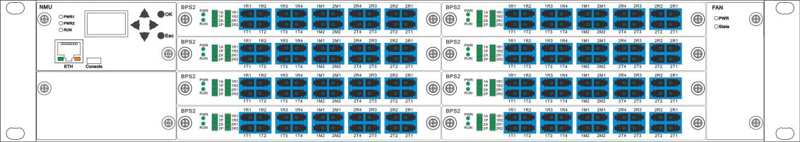

4U
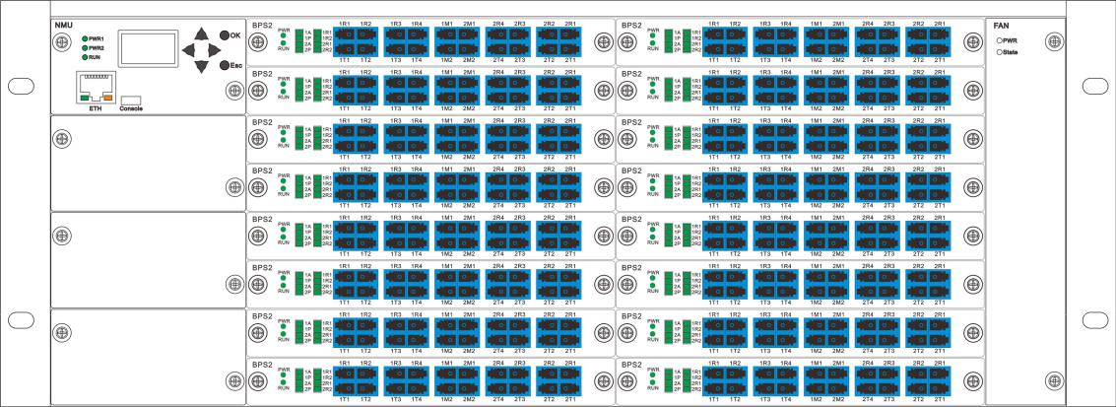

Rear Panel:

1U
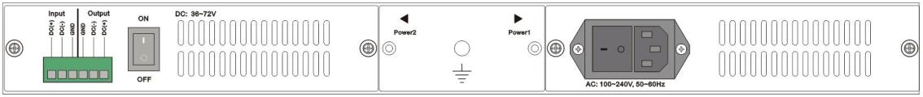

6/27

2U
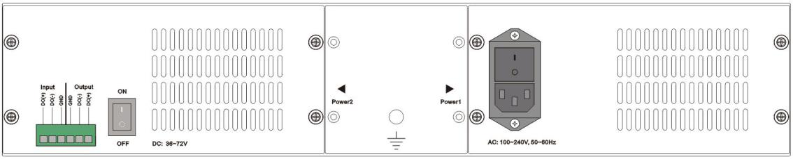

4U
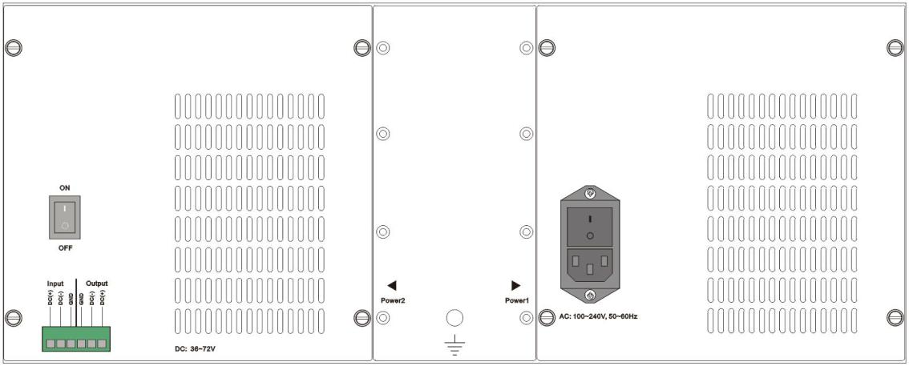

- LCD screen: device address, the current channel and related information display.

- NUM Indicator LED:

PWR1/PWR2：Indicate working status of Power , LED on means Power is on. LED off means Power is off.

RUN: LED Flickering indicate the device normal working status.

(3)NMU Buttons:

OK- confirm or return button;

Esc- confirm or return button;

▲, ▼, ◄, ►—menu move button;

(4)OBP card LED :

RUN: LED Flickering indicate the device normal working status.

Auto：Indicate equipment working mode, LED on means equipment is under automatic mode.

LED off means equipment under manual mode.

Pri：Indicate equipment channel status, LED on is in primary, LED off is in Bypass.

R1/R2: Indicate optical receiving status of R1and R2 port, LED on is normal condition , LED off is abnormal condition;

7/27

(5)RJ45 Ethernet interface : the communication port of the device;

(6)The power interface: AC220V、DC48V ;

4.2 Equipment Connection Instructions

4.2.1 Internal optical path instructions
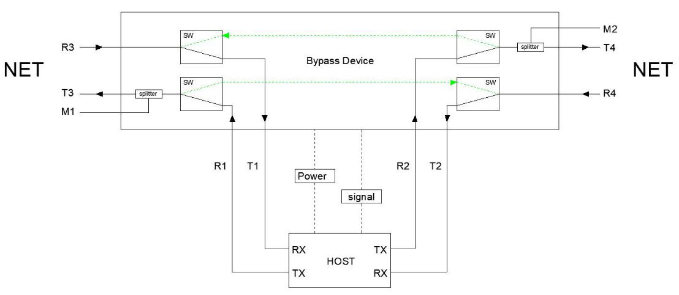

OBP Internal optical path connection diagram

Pri. (online)status: | T1 | R3 | T2 | R4
 | R1 | T3/M1 | R2 | T4/M2
Bypass status: | T3/M1 | R4
 | R3 | T4/M2
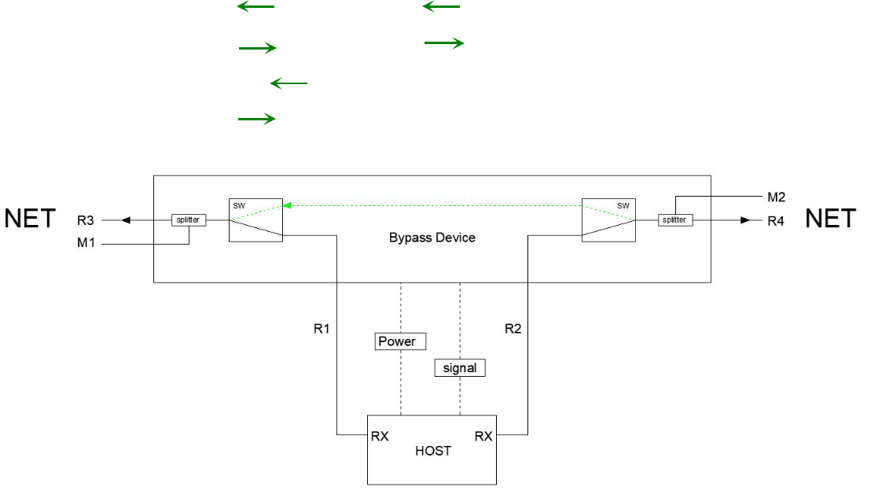

OBP-BIDI Internal optical path connection diagram

Pri. (online)status: | R1 | R3/M1 | R2 | R4 /M2
Bypass status: | T3/M1 | R4/M2

4.2.2 Communication interface instructions

8/27

(1) RJ45 Ethernet interface

When bypass device and computer connected via a exchange device, users should use the trough line (both ends of the wiring order: 1 - orange and white, 2 - orange 3 - green and white, 4 - blue 5 - white and blue, 6 - Green 7 - Brown white 8 - brown);

When bypass device and your computer connected directly, users should use a crossover cable (one end: 1 - orange and white, 2 - orange 3 - green and white, 4 - blue 5 - white and blue 6 - green 7 - brown white 8 -brown; the other end as follows: 1 - green and white, 2 - Green 3 - orange and white 4 - blue 5 - white and blue, 6 - Orange 7 - brown white 8 -brown).

(2) Support SFP port

When bypass device and computer connected via a exchange device, the SFP module type of the device and exchange device should be the same .

4.3 LCD Instructions

4.3.1 main information interface ( Press button ▲,▼,◄,►to switch the page )
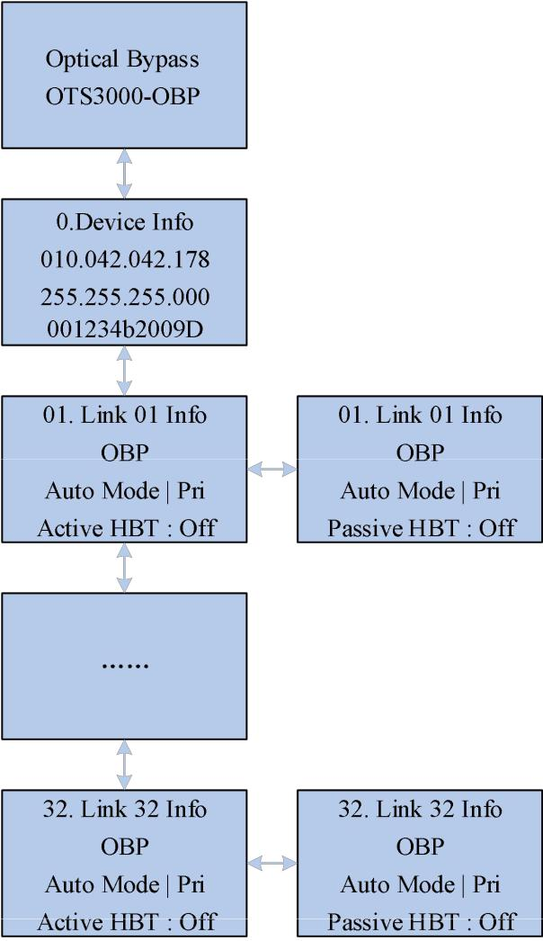

9/27

4.3.2 The device NMU instructions
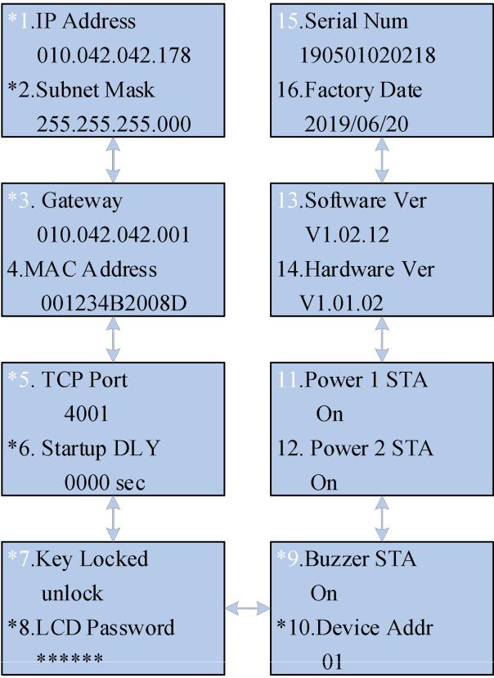

4.3.3 To set the IP address

Press “Enter/Esc” to the setting page, Press button ▲,▼ to modify the data. Press button◄,

- to switch the digit
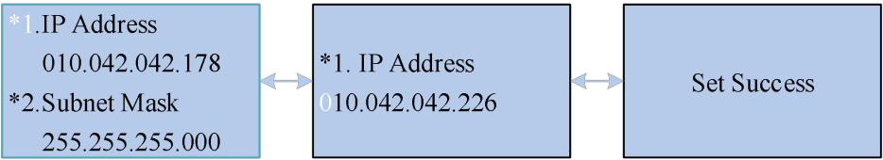

4.3.4 To set the subnet mask

Press “Enter/Esc” to the setting page, Press button ▲,▼ to modify the data. Press button◄,

- to switch the digit
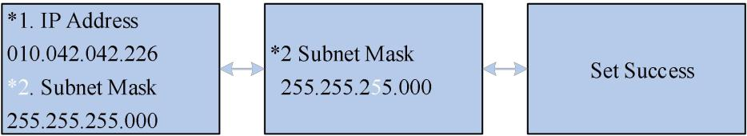

10/27

4.3.5 The default gateway settings.

Press “Enter/Esc” to the setting page, Press button ▲,▼ to modify the data. Press button◄,

- to switch the digit
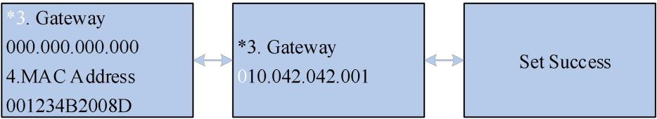

4.3.6 The communication port settings.

Press “Enter/Esc” to the setting page, Press button ▲,▼ to modify the data. Press button◄,

- to switch the digit
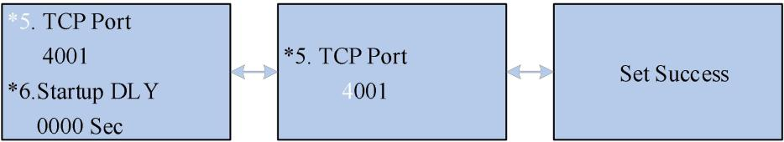

4.3.7 To set the boot on delay.

Press “Enter/Esc” to the setting page, Press button ▲,▼ to modify the data. Press button◄,

- to switch the digit
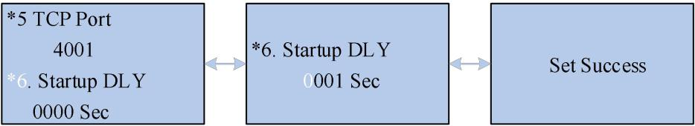

4.3.8 The buttons locking settings.

Press “Enter/Esc” to the setting page, Press button ▲,▼ to modify the data.


4.3.9 To set the LCD password

Press “Enter/Esc” to the setting page, Press button ▲,▼ to modify the data. Press button◄,

- to switch the digit


11/27

4.3.10 To set the alarm switch

Press “Enter/Esc” to the setting page, Press button ▲,▼ to modify the data.
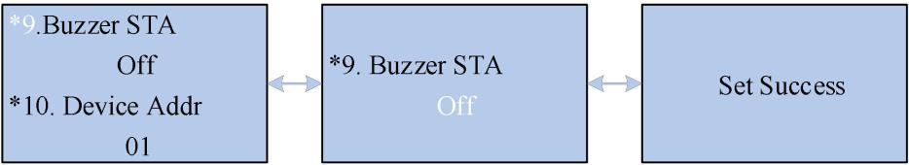

4.3.11 The device address settings.

Press “Enter/Esc” to the setting page, Press button ▲,▼ to modify the data. Press button◄,

- to switch the digit
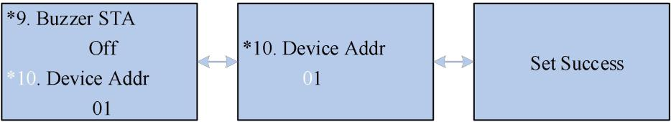

12/27

4.3.12 The OBP card information ( press button ▲,▼ to switch the page)
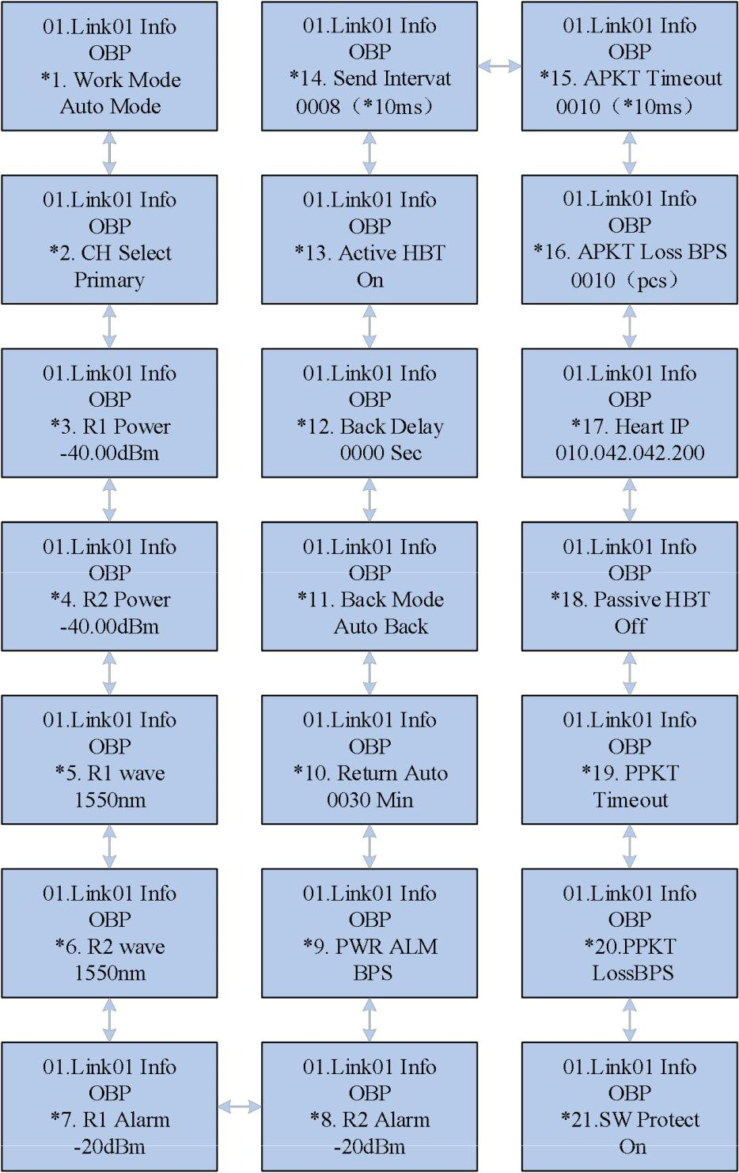

13/27

4.3.14 The working mode settings

Press “Enter/Esc” to the setting page, Press “UP/Down” to modify the data. Each path of the device has two kind of working mode: the automatic mode , manual mode, the manual mode is apply to the device testing and the forced switch,
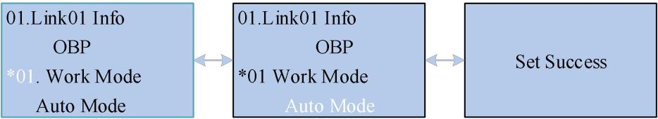

4.3.15 To set the path with manual operation.

Press “Enter” to the setting page, Press “UP/Down” to modify the data. Press “Enter” to switch figure and keep it and finally exit. Each path provided two kind of optical status: primary path and secondary path. Under the primary path status, the signal will go through the bypass switch and then come into the home station transmission device, while the secondary path, the signal go through the bypass switch then transmit to the next station.
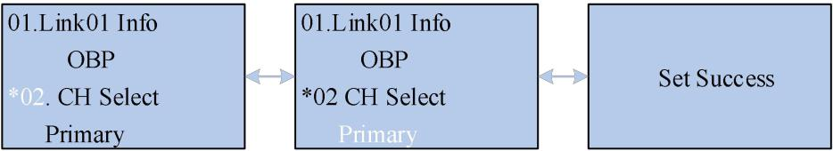

4.3.16 To set the wavelength of optical path

Press “Enter/Esc” to the setting page, press button ▲,▼ to set the wavelength
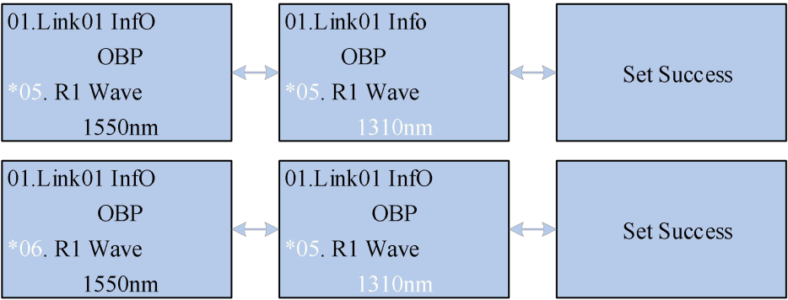

4.3.17 To set the switch threshold

Press “Enter/Esc” to the setting page, Press button ▲,▼ to modify the data. Press button◄,

- to switch the digit
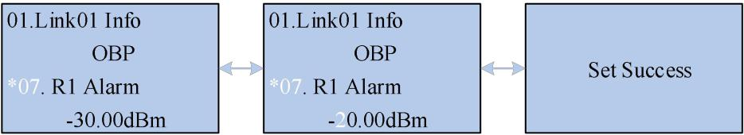

14/27

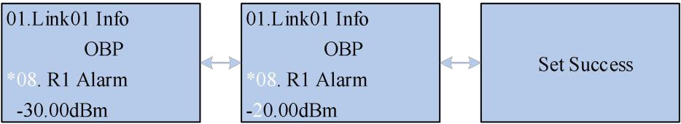

4.3.18 To set the bypass without optical signal

Press “Enter/Esc” to switch the page, Press button ▲,▼ to set the status.
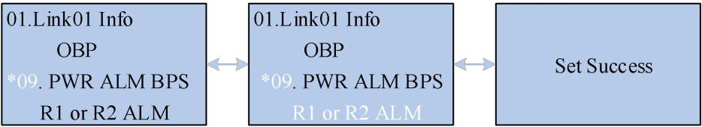

4.3.19 Return to the automatic mode settings.

Press “Enter/Esc” to the setting page, Press button ▲,▼ to modify the data. Press button◄,

- to switch the digit. To set each path delay time from manual mode to automatic mode, the default time be 30 minutes.
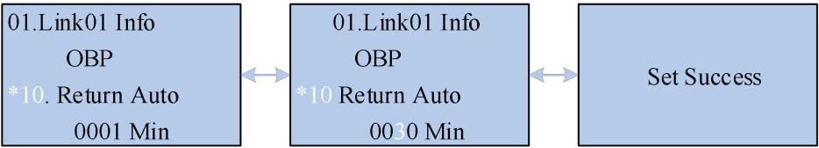

4.3.20 Cutback mode settings

Press “Enter/Esc” to switch the page, Press button ▲,▼ to modify the data. The definition of cutback, when under the automatic mode, the device will switch from the bypass path to the primary path., every path can be set to be “automatic cutback” or “manual cutback”, while under the manual cutback mode, even the device meet the cutback condition, it wont automatically switch from the bypass path to the primary path.
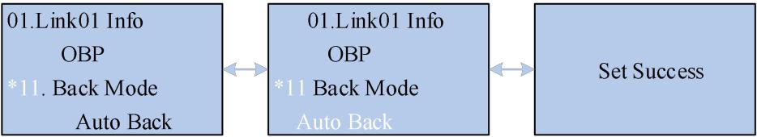

4.3.21 Cutback delay settings.

Press “Enter/Esc” to the setting page, Press button ▲,▼ to modify the data. Press button◄, ► to switch the digit. Every path can be set to be automatic cutback delay time (0~9999 second), 0 second means there is no cutback delay.
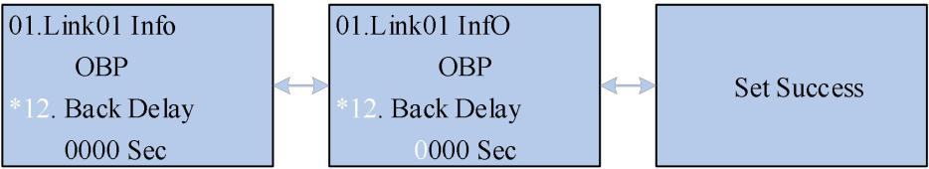

15/27

4.3.22 Automatic signal switch settings

Press “Enter/Esc” to the setting page, Press button ▲,▼ to modify the data, to open the automatic signal switch settings
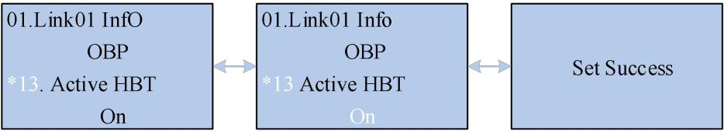

4.3.23 Automatically send packet interval settings

Press “Enter/Esc” to the setting page, Press button ▲,▼ to modify the data. Press button◄,

- to switch the digit. To set every path packet sending interval time, the unit be 10ms.
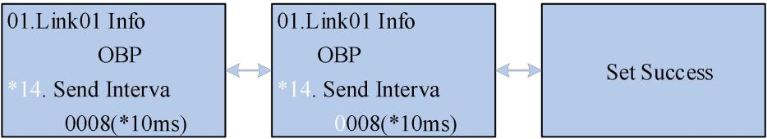

4.3.24 Automatically receive packet surpass time settings

Press “Enter/Esc” to the setting page, Press button ▲,▼ to modify the data. Press button◄,

- to switch the digit. To set every path packet sending interval time, the unit be 10ms.
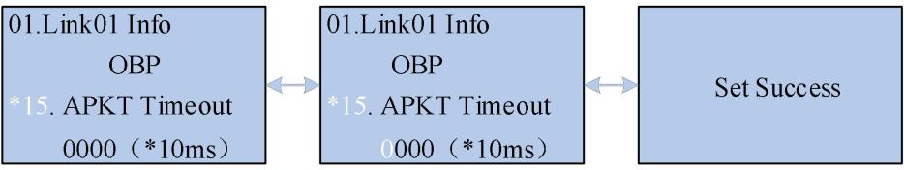

4.3.25 Automatically loose packet bypass settings.

Press “Enter/Esc” to the setting page, Press button ▲,▼ to modify the data. Press button ◄, ► to switch the digit. To set every path continuous packet loosing quantity threshold, if the quantity pass the threshold, the device will switch to the bypass path.
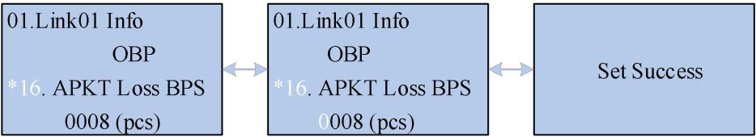

16/27

4.3.26 The Heart IP settings.

Press “Enter/Esc” to the setting page, Press button ▲,▼ to modify the data, to open the passive signal switch function.
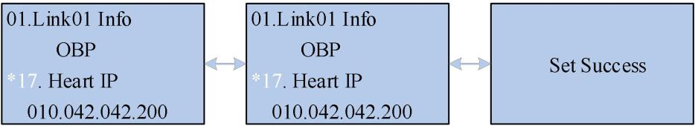

4.3.27 The passive heart switch settings.

Press “Enter/Esc” to the setting page, Press button ▲,▼ to modify the data, to open the passive signal switch function.
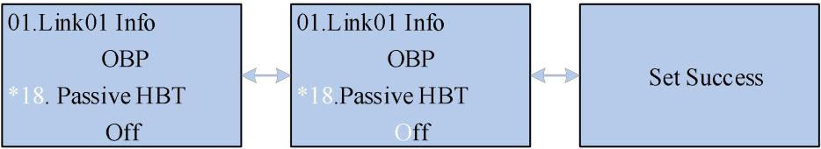

4.3.28 The passive signal timeout settings.

Press “Enter/Esc” to the setting page, Press button ▲,▼ to modify the data. Press button◄, ► to switch the digit.To set every path to receive the passive signal out time, the unit be 10ms.
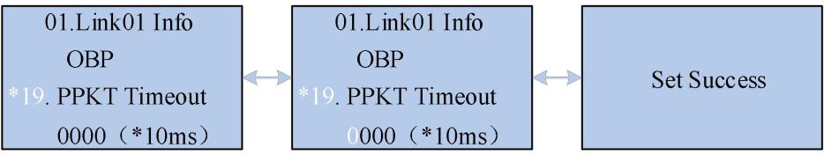

4.3.29 The passive packet loss bypass settings.

Press “Enter/Esc” to the setting page, Press button ▲,▼ to modify the data. Press button◄, ► to switch the digit. To set the continuous packet loss threshold quantity of every path, if the the quantity pass it then the device will switch to the bypass path.
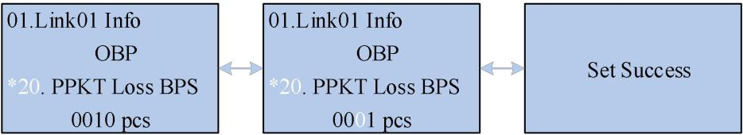

17/27

4.3.30 Switching protection settings.

Press “Enter/Esc” to the setting page, Press button ▲,▼ to modify the setting.
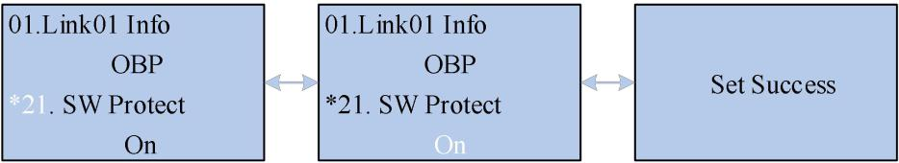

4.4 The host computer monitoring instructions

This device can receive control signals from the computer through the RJ45 interface to achieve the automatic measurement or real-time monitoring.

4.4.1 Programmed instruction

- 1 ）The programmed command is transmitted with TCPIP protocols, the protocols No, be 4001.

- 2）This device can only execute one command. Usually only if it returns to correspondent data then you can enter the next command.

- 3）Input any command by capital letters, and “_” is underlining.

- 4) In actual operation, the command input begins with "<" and ends with ">" .Programmed

Commands Table

Command | Description | E.g.
 | The device command address query.
 | return：<BPXX_OK> | return：<BP01_OK>
<BP_ADR_?> | 1.XX can be 00~99, indicate the | The present device command address
 | device command address. | be 01.
 | The device restores to factory
<RESTORE> | defaults.
 | To change the device command
 | address:
 | 1.XX 、 YY can be 00~99 indicate the
 | device command address, XX be the
 | present device address, YY be the | To send command <BP01_ADR_02>
<BPXX_ADR_YY> | new setting device address; | to change the device address as 02，
 | 2.when YY can be ？ to query the | Return ：<BP02_ADR_OK>
 | present device address;
 | 2.Return ：<BPXX_ADR_OK>
 | 3.Return with a failure：<CMD_ERR>
 | Reset
<BP01_RESET> | 1.without any returning information, | To send command <BP01_RESET> to
<BP01_RESET> | the device is to reset. | reset device of No.01 address.
<BP01_KEY_X> | Buttons operation permission setting | To send command <BP01_KEY_0> to

18/27

 | and query. |  |  |  |  |  |  | set the button of the device on No.01
 | 1.X can be 0,1,? to indicate |  |  |  |  |  |  | address is prohibited to use.
 | prohibition, permission, query
 | 2.Return ：<BP01_KEY_OK>
 | 3.Return with a failure：<CMD_ERR>
 | To close the buzzer alarm one time
<BP01_BEEONE_OFF> | <BP01_BEEONE_OFF_OK>
 | Buzzer alarm setting and query:
<BP01_BEE_X> | 1.X can be 0,1,? to indicate close, on, |  |  |  |  |  |  | To send command <BP01_BEE_0> to
<BP01_BEE_X> | and query. |  |  |  |  |  |  | close the buzzer alarm.
 | Manual/automatic |  |  | mode | setting and
 | query:
 | 1.X be the optical path number;
 | 2.Y can be 1,0,? to indicate the |  |  |  |  |  |  | To send command <BP01_1_M_1> to
<BP01_x_M_Y> | automatic mode, manual mode and |  |  |  |  |  |  | set the No. 1 path be automatic mode of
<BP01_x_M_Y> | query; |  |  |  |  |  |  | the device on the No.01 address;
 | 3.Return ：<BP01_1_M_OK> |  |  |  |  |  |  | Return：<BP01_1_M_OK>
 | 4.Return |  | with | a failure |  | ： | <
 | BP01_CMD_ERR>
 | The working status of each optical
 | path setting and query.
 | 1. Y can be 0/1
 | (0) indicates the device on the
 | secondary path, the working mode be
 | manual mode;
 | (1) | automatically |  | switch | the | status, |  | To send command <BP01_1_S_0> to
 | and | the | working | mode | changes |  | to | To send command <BP01_1_S_0> to
 |  |  |  |  |  |  |  | set the No. 1 path to “Sec.path”,the
<BP01_x_S_Y> | automatic mode; |  |  |  |  |  |  | set the No. 1 path to “Sec.path”,the
<BP01_x_S_Y> |  |  |  |  |  |  |  | working mode change to manual mode;
 | Setting OK ：<BP01_1_S_OK> |  |  |  |  |  |  | working mode change to manual mode;
 |  |  |  |  |  |  |  | Successful return：<BP01_1_S_OK>
 | Setting |  | with | a | failure |  | ： | Successful return：<BP01_1_S_OK>
 | <BP01_1_S_ER>
 | 2. Y be ？to query the present status,
 | Query |  | is | successful |  |  | ：
 | <BP01_X_S_0/1>
 | Query is fail：<BP01_X_S_ER>
 | Force to switch the pri. or sec. status
 | of each path:
 | 1. Y can be 0/1
 | (0) indicate the device is on secondary
 | status, the working mode be manual
 | mode; |  |  |  |  |  |  | To send command <BP01_1_QS_1> to
 | (1) indicate the device is on primary |  |  |  |  |  |  | switch the No.1 path to “pri.” ,its
<BP01_x_QS_Y> | status , working mode be manual |  |  |  |  |  |  | working mode be changed to manual
<BP01_x_QS_Y> | mode; |  |  |  |  |  |  | mode;
 | Setting OK：<BP01_X_QS_OK>
 | Setting is fail：<BP01_X_QS_ER> |  |  |  |  |  |  | Setting OK：<BP01_1_S_OK>
 | 2. Y be ？to query the present status:
 | The |  | successful |  | query |  | ：
 | <BP01_X_QS_0/1>
 | The fail query ：<BP01_X_QS_ER>
<BP01_x_ACC_Y> | Cutback ways setting and query: |  |  |  |  |  |  | To send command <BP01_1_ACC_0>
<BP01_x_ACC_Y> | 1.Y can be 0,1,? to indicate cutback |  |  |  |  |  |  | to set the No. 1 path be manual

19/27

 | manually , cutback automatically and |  |  |  |  | cutback,that is when the device is
 | query; |  |  |  |  | change to sec. status under automatic
 | 2.Setting OK：<BP01_X_ACC_OK> |  |  |  |  | mode, users need to switch the device
 | 3. Setting is fail：<CMD_ERR> |  |  |  |  | to Primary path -Pri. Status manually.
 | Automatic cutback delay setting and
 | query:
 | 1.YYYY be the delay time, the unit be
 | second; |  |  |  |  | To send command <BP01_1_Q_0000>
<BP01_x_Q_YYYY> | Successful |  |  |  | return: | to set the delay time be 0 second of
<BP01_x_Q_YYYY> | <BP01_1_Q_OK> |  |  |  |  | No.1 path from secondary path- BPS to
 | Fail return: <CMD_ERR> |  |  |  |  | primary path- Pri.
 | 2.To send command <BP01_1_Q_?>
 | to query the No.X path automatic
 | cutback delay;
 | Manual mode returns to automatic
 | mode delay setting and query: |  |  |  |  | To send command <BP01_1_R_0030>
 | 1.YYYY be the delay time, the unit be
 |  |  |  |  |  | to | set the | time of No.1 path of |  | the
 | minute; 0000 means no return.
 |  |  |  |  |  | device on the No. 01 address returning
<BP01_x_R_YYYY> | Setting OK ：<BP01_1_R_OK>
<BP01_x_R_YYYY> |  |  |  |  |  | from manual mode to automatic mode
 | Setting is fail：<CMD_ERR>
 |  |  |  |  |  | be 30 min.
 | 2.to send command <BP01_1_R_?>
 | to query the manual return delaying of
 | No. X path;
 | Booting delay setting and query:
 | 1.XXXX be the delay time, the unit be |  |  |  |  | To send command <BP01_SY_0000>
 | second;
 | second; |  |  |  |  | to set the device booting delay be “0
<BP01_SY_XXXX> | Setting OK: <BP01_SY_OK>
<BP01_SY_XXXX> |  |  |  |  |  | second”,then the device will switch the
 | Setting is fail: <CMD_ERR>
 |  |  |  |  |  | automatic mode accordingly.
 | 2.To send command <BP01_SY_?> to
 | query the booting time delay;
 | To query | the current path: |  |  |  | To |  | send | command
 | Return：<BP01_1_LINKSTS_Y_Z> |  |  |  |  | <BP01_1_LINKSTS_?> ,
<BP01_x_LINKSTS_?> | Y can be 1, 0 to indicate the automatic |  |  |  |  | Return：<BP01_1_LINKSTS_1_0>
<BP01_x_LINKSTS_?> | mode and manual mode; |  |  |  |  | indicates the No.1 path is on the
 | Z can be 0,1 to indicate the sec. |  |  |  |  | automatic mode and at secondary path
 | Status and pri.(online) status; |  |  |  |  | status;
 | To set | and | query the | device IP |  | To send command
 |  |  |  |  |  | <BP01_IP_192_168_002_011> to set
 | address:
 | address: |  |  |  |  | IP address be 192.168.002.011；
 | 1.XXX can |  | be 000~255 | to | set IP
<BP01_IP_XXX_XXX_XXX_ |  |  |  |  |  | To send command <BP01_IP_?> ,its
<BP01_IP_XXX_XXX_XXX_ | address;
XXX> | address; |  |  |  |  | Responding be
XXX> | 2.Setting OK：<BP01_IP_OK>
 |  |  |  |  |  | <BP01_IP_192_168_002_011> to
 | 3.<BP01_IP_?> is to query |  |  |  | the IP
 |  |  |  |  | the IP | indicate the IP address be
 | address;
 | address; |  |  |  |  | 192.168.002.011;
 |  |  |  |  |  | To |  | send | command
 | To set and query the gateway |  |  |  |  | <BP01_GW_192_168_002_001> to set
 |  |  |  |  |  | the gateway be 192.168.002.001；
 | 1.XXX can be 000~255 to set the
<BP01_GW_XXX_XXX_XX | gateway; |  |  |  |  | To | send | <BP01_GW_?>, | and | its
X_XXX> | 2.Setting OK ：<BP01_GW_OK>
X_XXX> |  |  |  |  |  | responding |  |  |  | be
 | 3.Command <BP01_GW_?> to query |  |  |  |  |  |  |  |  | be
 |  |  |  |  |  | <BP01_GW_192_168_002_001>, |  |  |  | that
 | the gateway address; |  |  |  |  |  |  |  |  | that
 |  |  |  |  |  | means the current gateway be
 |  |  |  |  |  | 192.168.002.001；
 | To set and query the subnet mask: |  |  |  |  | To |  |  | send
<BP01_SM_XXX_XXX_XXX | 1.XXX can be 000~255to indicate the |  |  |  |  | <BP01_SM_255_255_255_000> to set
_XXX> | subnet mask; |  |  |  |  | the subnet mask be 255.255.255.000；
 | 2. Setting OK：<BP01_SM_OK>

20/27

 | 3. Command <BP01_SM_?> to query |  |  |  |  |  |  |  | To send <BP01_SM_?>, and it returns
 | the subnet mask; |  |  |  |  |  |  |  | as
 |  |  |  |  |  |  |  |  | <BP01_SM_255_255_255_000>,which
 |  |  |  |  |  |  |  |  | means the current subnet mask be
 |  |  |  |  |  |  |  |  | 255.255.255.000
 |  |  |  |  |  |  |  |  | To | send |  | command |  | ：
 | To set and query the PING IP address |  |  |  |  |  |  |  | <BP01_PIP1_192_168_002_012> |  |  |  |  | to
 |  |  |  |  |  |  |  |  | set the PING IP address of No.1 optical
 | of each optical path:
 |  |  |  |  |  |  |  |  | path be 192.168.002.012；
<BP01_PIP1_XXX_XXX_XX | 1.XXX can be 000~255tp indicate the
<BP01_PIP1_XXX_XXX_XX | PING IP address
X_XXX> |  |  |  |  |  |  |  |  | To send |  | command | <BP01_PIP1_?>
X_XXX> | 2. Setting OK：<BP01_PIP1_OK> |  |  |  |  |  |  |  |  |  | command
 |  |  |  |  |  |  |  |  | and | it | returns |  | command
 | 3.Command |  |  |  | <BP01_PIP1_?> |  |  | to
 |  |  |  |  |  |  |  | to | <BP01_PIP1_192_168_002_012>,whic
 | query the PING IP address;
 |  |  |  |  |  |  |  |  | h means the PING IP of No. 1 path be
 |  |  |  |  |  |  |  |  | 192.168.002.012
 | To set and query TCP communication
 | port No. |  |  |  |  |  |  |  | To |  | send |  | command
 | 1.XXXXX |  |  | can | be | 00000~65534 |  | to | To |  | send
 |  |  |  |  |  |  |  |  | <BP01_TCPP_04001> to send the TCP
<BP01_TCPP_XXXXX> | indicate TCP communication port No.
<BP01_TCPP_XXXXX> |  |  |  |  |  |  |  |  | communication port No. be 4001;
 | 2. Setting OK：<BP01_TCPP_OK>
 | 3. Command <BP01_TCPP_?> to
 | query TCP communication port No.
 | To set |  | and query |  |  | the signal | interval |  | To send command <BP01_1_HI_0001>
 | time
 |  |  |  |  |  |  |  |  | to set the signal interval time of the No.
 | 1.YYYY can be 0001~9999（10ms be
 |  |  |  |  |  |  |  |  | 1 be 10 ms;
 | a unit ） to indicate the signal interval
<BP01_x_HI_YYYY> | time; |  |  |  |  |  |  |  | Send command <BP01_1_HI_?>
 | Setting OK：<BP01_1_HI_OK>
 |  |  |  |  |  |  |  |  | Return <BP01_1_HI_0001> command,
 | 2. | Command |  |  | <BP01_1_HI_?> |  |  | to
 |  |  |  |  |  |  |  |  | to set the current signal interval of No.1
 | query |  | the | signal interval time |  |  | of | the
 |  |  |  |  |  |  |  |  | path be 10 ms;
 | path;
 | To | set | and query |  |  | the surpass time |  |  | To |  | send |  | command
 |  |  |  |  |  |  |  |  | <BP01_1_PO_0001> to set the surpass
 | standard of receiving data packet :
 |  |  |  |  |  |  |  |  | time standard of receiving data packet
 | 1.YYYY can be 0000~9999（10ms be
 |  |  |  |  |  |  |  |  | of No. 1 path be 10 ms;
 | a unit) to indicate the surpass time
<BP01_x_PO_YYYY> | standard of receiving data packet; |  |  |  |  |  |  |  | Send command <BP01_1_PO_?>
 | Setting OK：<BP01_1_PO_OK>
 |  |  |  |  |  |  |  |  | Return <BP01_1_PO_0001> command
 | 2.Command |  |  |  | <BP01_1_PO_?> |  |  | to
 |  |  |  |  |  |  |  | to | to set | the | surpass | time | standard | of
 | query |  | the | surpass |  | time standard |  | of
 |  |  |  |  |  |  |  |  | receiving data packet of No.1 path be
 | receiving data packet;
 |  |  |  |  |  |  |  |  | 10 ms;
 | To set and query the continuous
 | packet loss quantity of the secondary |  |  |  |  |  |  |  | Send command <BP01_1_LP_0003>
 | path: |  |  |  |  |  |  |  | to set the continuous packet loss of the
 | 1.YYYY can be 0001~9999 to indicate |  |  |  |  |  |  |  | secondary path on No. 1 path be 3 pcs ;
 | the continuous packet loss quantity of
<BP01_x_LP_YYYY> | the secondary path; |  |  |  |  |  |  |  | Send command <BP01_1_LP_?>
 | Setting OK ：<BP01_1_LP_OK> |  |  |  |  |  |  |  | Return <BP01_1_LP_0003> command
 | 2. Command <BP01_1_LP_?> to |  |  |  |  |  |  |  | to set the continuous packet loss of the
 | query the continuous packet loss |  |  |  |  |  |  |  | secondary path on No. 1 path be 3 pcs;
 | quantity of the secondary path;
 | To set and query the active signal ON
<BP01_x_SC_Y> | and Off :
<BP01_x_SC_Y> | Y=1means ON；Y=0 means Off;
 | Setting OK：<BP01_X_SC_OK>
<BP01_x_PPO_YYYY> | To set and query the surpass time |  |  |  |  |  |  |  | Send command <BP01_1_PPO_0001>
<BP01_x_PPO_YYYY> | standard |  |  | of | the | passive | signal |  | to set | the | surpass | time | standard | of

21/27

 | receiving data packet : |  |  |  |  |  |  | receiving data packet of No. 1 path be
 | 1.YYYY can be 0000~9999（10ms be |  |  |  |  |  |  | 10 ms;
 | a unit ） to indicate the surpass time
 | standard of receiving data packet; |  |  |  |  |  |  | Send command <BP01_1_PPO_?>
 | Setting OK：<BP01_1_PO_OK> |  |  |  |  |  |  | Return | <BP01_1_PPO_0001>
 | 2.Command <BP01_1_PO_?> to |  |  |  |  |  |  | command
 | query the surpass time standard of |  |  |  |  |  |  | to set the surpass time standard of
 | receiving data packet; |  |  |  |  |  |  | receiving data packet of No.1 path be
 |  |  |  |  |  |  |  | 10 ms;
 | To | set | and | query | the continuous |  |  | Send command <BP01_1_PLP_0003>
 | packet |  | loss quantity |  | of | the passive
 |  |  |  |  |  |  |  | to set the continuous packet loss of the
 | signal on the secondary path:
 |  |  |  |  |  |  |  | secondary path on No. 1 path be 3 pcs ;
 | 1.YYYY can be 0001~9999 to indicate
 | the continuous packet loss quantity of |  |  |  |  |  |  | Send command <BP01_1_PLP_?>
<BP01_x_PLP_YYYY> | the secondary path;
<BP01_x_PLP_YYYY> |  |  |  |  |  |  |  | Return | <BP01_1_PLP_0003>
 | Setting OK：<BP01_1_LP_OK> |  |  |  |  |  |  | Return | <BP01_1_PLP_0003>
 |  |  |  |  |  |  |  | command
 | 2. | Command |  | <BP01_1_LP_?> |  |  | to | command
 |  |  |  |  |  |  |  | to set the continuous packet loss of the
 | query |  | the continuous |  |  | packet | loss
 |  |  |  |  |  |  |  | secondary path on No. 1 path be 3 pcs;
 | quantity of the secondary path;
 | To set and query the active signal ON
 | and Off :
<BP01_x_PSC_Y> | Y=1means ON；Y=0 means Off;
 | Setting OK：<BP01_X_PSC_OK>
 | The feed the dog command of X
<BP01_X_BP> | optical path( be used to send the
 | signal to the protected server)
 | Setting ok：<BP01_X_BP_OK>
 |  |  |  |  |  |  |  | Send | command
 | To set and query the protection |  |  |  |  |  |  | <BP01_1_PROTECT_0> to set the
 | function of the optical switch: |  |  |  |  |  |  | protection function of the optical switch
 | 1.Y can be 1 , 0 to indicate ON or Off; |  |  |  |  |  |  | on No.1 link be close;
<BP01_x_PROTECT_Y> | 2. |  | Setting |  |  | OK | ： | note：the protection function of the
 | <BP01_X_PROTECT_OK> |  |  |  |  |  |  | optical switch, when under the
 | 3. | Setting |  | with |  | error | ： | automatic mode, if the switching times
 | <BP01_CMD_ERR> |  |  |  |  |  |  | are more than 10, the device will switch
 |  |  |  |  |  |  |  | to “Manual mode”.
 | To query the configured link quantity |  |  |  |  |  |  | Send command <BP01_LINK_?>
<BP01_LINK_?> | of the device: |  |  |  |  |  |  | Return command <BP01_LINK_4> to
<BP01_LINK_?> | 1.Setting OK |  |  | ： <BP01_LINK_the |  |  |  | indicate the actual link quantity of this
 | actual link quantity > |  |  |  |  |  |  | device be 4 ;
 | To set and query the bypass without
 | optical:
 | Y can be 0,1,2,3,4 |  |  |  |  |  |  | Setting ok:：<BP01_1_PA_OK>
<BP01_x_PA_Y> | 0：close. 1：R1without optical . 2：R2
 | without optical .
 | 3：eitherR1or R2 without optical. 4：
 | both R1and R2 without optical.
 | To query the current optical power of |  |  |  |  |  |  | Send command < BP01_1_R1_P_?>
 | R1on the link |  |  |  |  |  |  | Return command
<BP01_x_R1_P_?> | 1.Command <BP01_1_R1_P _?> to |  |  |  |  |  |  | <BP01_1_R1_P_-20.00> to set the
 | query the current optical power of R1 |  |  |  |  |  |  | current optical power of R1 on No.1 link
 | on the link; |  |  |  |  |  |  | be -20.00dBm
<BP01_x_R1_SP_-YY.YY > | To set and query the switching optical |  |  |  |  |  |  | Send command
<BP01_x_R1_SP_-YY.YY > | power threshold of R1 on some link : |  |  |  |  |  |  | <BP01_1_R1_SP_-20.00> to set the

22/27

 | 1.-YY.YY can be -50.00~+23.00 to set | switching optical power of R1 on NO.1
 | the switching optical power threshold | link be -20.00dBm；
 | of R1;
 | Setting OK：< BP01_1_R1_SP _OK> | Send command < BP01_1_R1_SP_?>
 | 2. Command < BP01_1_R1_SP _?> | Return command
 | to query the switching optical power of | <BP01_1_R1_SP_-20.00> to set the
 | R1; | switching optical power of R1 on No.1
 |  | link be -20.00dBm；
 | To query the current optical power of | Send command < BP01_1_R2_P_?>
 | R2on the link | Return command
<BP01_x_R2_P_?> | 1. Command <BP01_1_R2_P _?>to | <BP01_1_R2_P_-20.00>
 | query the current optical power of R2 | to set the current optical power of R2
 | on the link; | on No.1 link be -20.00dBm;
 | To set and query the switching optical | Send command
 | To set and query the switching optical | <BP01_1_R2_SP_-20.00>
 | power threshold of R2 on some link : | <BP01_1_R2_SP_-20.00>
 | power threshold of R2 on some link : | to set the switching optical power of
 | 1.-YY.YY can be -50.00~+23.00 to set | to set the switching optical power of
 | 1.-YY.YY can be -50.00~+23.00 to set | R2 on NO.1 link be -20.00dBm；
 | the switching optical power threshold | R2 on NO.1 link be -20.00dBm；
<BP01_x_R2_SP_-YY.YY> | of R2; | Send command <BP01_1_R2_SP_?>
 | 2.Setting OK:< BP01_1_R2_SP _OK> | Send command <BP01_1_R2_SP_?>
 | 2.Setting OK:< BP01_1_R2_SP _OK> | Return command
 | 2.Command< BP01_1_R2_SP _?> to | Return command
 | 2.Command< BP01_1_R2_SP _?> to | <BP01_1_R2_SP_-20.00>
 | query the switching optical power of | <BP01_1_R2_SP_-20.00>
 | query the switching optical power of | to set the switching optical power of
 | R2; | to set the switching optical power of
 | R2; | R2 on No.1 link be -20.00dBm；
 | To set and query the wavelength of R1
 | on x link: | To send <BP01_1_R1_W_1> to set the
 | 1.Y=0 to set the wavelength be | wavelength of R1 be 1550nm
<BP01_x_R1_W_Y> | 1310nm; 1 to set it be1550nm; | Send command <BP01_1_R1_W_?>
<BP01_x_R1_W_Y> | Setting OK：< BP01_1_R1_W _OK> | Return command <BP01_1_R1_SP_1>
 | 2. Command < BP01_1_R1_W_?> to | to query the wavelength of R1 be
 | query the wavelength of R1 on the | 1550nm;
 | link.
 | To set and query the wavelength of | Send command <BP01_1_R2_W_1> to
 | R2on x link: | set the wavelength of R2 on No.1link be
 | 1.Y=0 to set the wavelength be | 1550nm;
<BP01_x_R2_W_Y> | 1310nm; 1 to set it be1550nm;
<BP01_x_R2_W_Y> | Setting OK：< BP01_1_R2_W _OK> | Send command <BP01_1_R2_W_?>
 | 2. Command < BP01_1_R2_W_?> to | return command <BP01_1_R2_SP_1>
 | query the wavelength of R2 on the | To query the wavelength of R2 be
 | link; | 1550nm;
Attentions！

（1） The“01”in BP01 indicates the device command address, if the device address changes, then command address need to change accordingly;

4.4.2. Network port monitoring

Attention! The network port has already been set well, users are only need to change the IP at the normal conditions.

When RJ45 Ethernet port monitoring, the equipment IP address and the IP address of the host computer equipment must be the same network segment, for example: the original IP address of the computer IP: 192.168.0.45, Subnet Mask: 255.255.255.0,Default Gateway: 192.168.0.1; the IP netmask, the gateway should be replaced by similar 192.168.0.11, 255.255.255.0, 192.168.0.1. The following are specific instructions.

（1）Set the computer's IP address

23/27

First, set the computer IP: 192.168.0.188, subnet mask: 255.255.255.0, default gateway: 192.168.0.1, DNS part can be blank. ( Attention: set IP should be in the same network segment with equipment default IP 192.168.0.188). As shown:
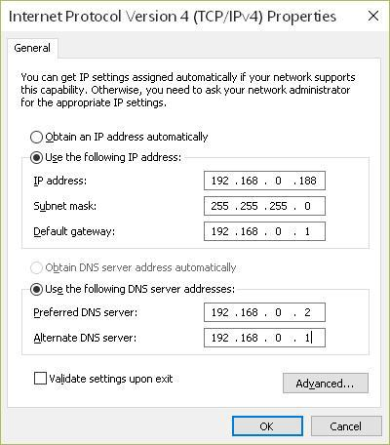

Change the computer IP diagram

(2) Set the device IP address

Connect the device with the computer well by the network port, On the right side of the USR-TCP232 software, there is a network test assistant part. To set the protocols be TCP Client , the server IP be the same as this device IP , the server port No. be 4001, When all is done , to send the relative commands, and the device will return the relative data to monitor the device. For example, to send the relative commands to modify the device IP to be 192.168.2.11, the subnet mask be 255.255.255.0, the default network gateway be 192.168.2.1, just as shown in the following picture:

24/27

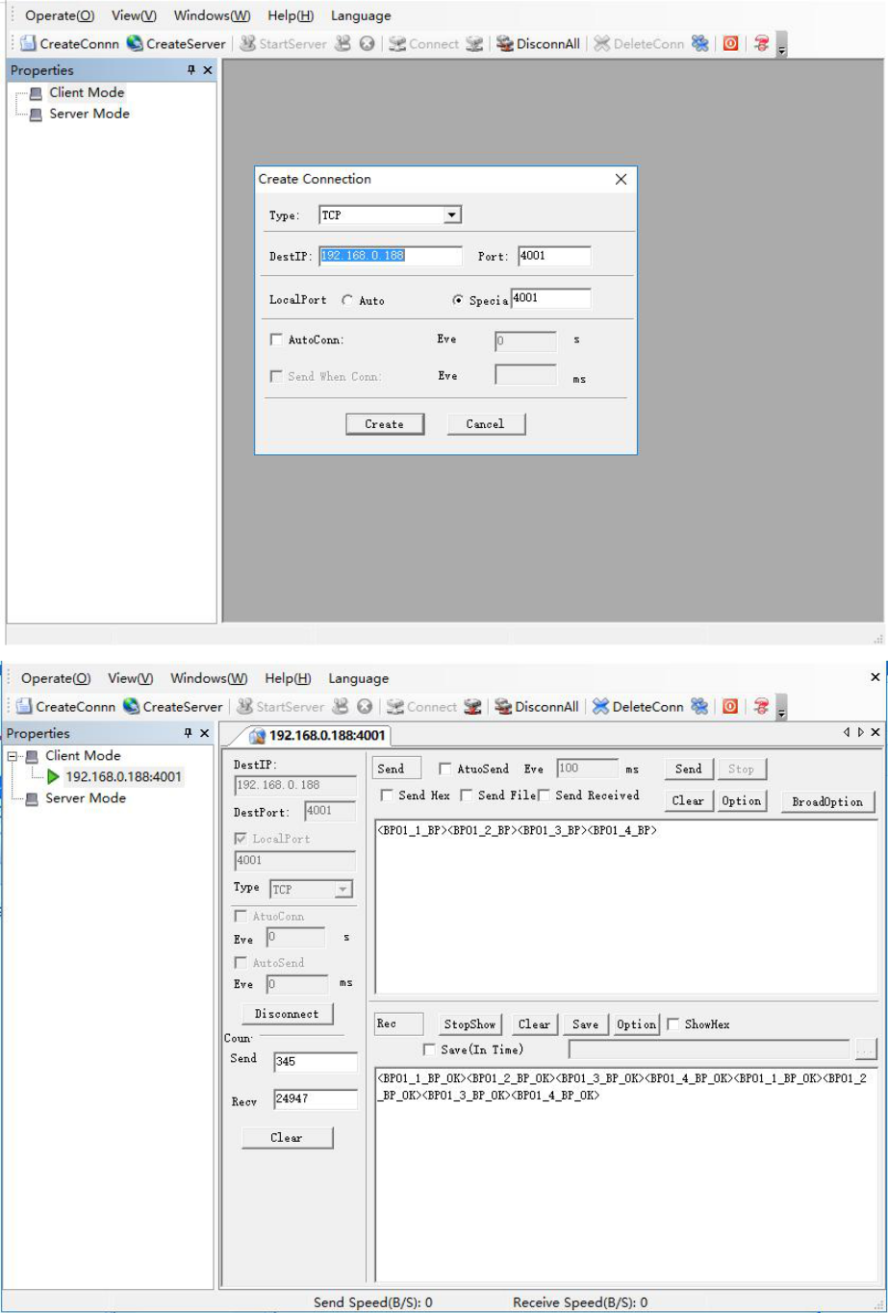

(3) Change the computer IP address

if the device IP address changed, the users need to change the computer IP address to be the same as the device address, then the computer can visit and change the device data. For example, in the previous step, the device IP address, subnet mask, and gateway have been changed to be 192.168.0.11, 255.255.255.0, 192.168.0.1 respectively, then the computer IP address , subnet mask , and gateway have to be changed to be the similar like 192.168.0.45, 255.255.255.0, 192.168.0.1, in this way the computer can connect and visit the device.

25/27

5. Precautions and Maintenance

5.1 Precautions

- Connect each port with the right optical line, when use this equipment.

- Ground connection and power supply should be in the required range.

- Power off first when there is sudden interference and the equipment becomes abnormal, then go on processing.

- Do connect input ports correctly, or test results and insertion loss will be incorrect.

- Slight vibration or noises is normal when switching optical channel.

5.2 Equipment maintenance

Reasonable use and good take-care of the equipment will maintain a long term good performance and extend its lifetime, therefore proper maintenance is vital important.

- Avoid strong mechanical vibration, crash, falling and other mechanical damage. Make sure the equipment with good package, vibration isolation, rain-proof and waterproof during transportation.

- Keep the equipment clean and operation environment without corrosive gas. Use clean towel with water or soap to clean equipment case and panel. Alcohol and other solvents are prohibited.

- Do coat the dust cap to avoid optical end face damaged, when remove optical fiber connection cable.

If any other questions, please feel free to contact us, we will be very glad to hear any suggestions from you.

6. Troubleshooting

Fault performance |  | Possible reasons |  | Solutions
No display when power on |  | Power is not connected |  | Re-connect the power, power on.
Insertion loss is too high |  | Dirty connector end face |  | Re-clean optical connector end face, and
 |  |  |  | fix it well. Check the connector damage or
 |  |  |  | not.
The host computer command |  | Network cable, serial cable is |  | Firstly power off, re-check |  |  | the | network
is invalid |  | not connected |  | cable, serial cable, then power on.
The optical path can’t | be | The cutback way is set to be |  | To set | the cutback | way be “automatic
switched on the primary path |  | “ manual cutback” and | the | cutback | mode” and | the | LCD | screen
 |  | client’s firewall is on. |  | indicates “automatic mode”.

26/27

Warranty

Warranty Period：1 year since the purchase date

- If the product went wrong under the correct operation during the warranty period, the user will have the right to get out free maintenance service by showing your warranty card and invoice.

- You have to pay for maintenance in case of followings conditions (the charges will depend on the material, maintenance and freight expense):
  - The product broken down under the correct operation, but out of warranty.

  - The warranty card was not showing, or missing, altering, or not clearly filling.

  - Misusing, such as factitious damage, or high-temperature, high pressure, humid circumstance. The charges will depend on the damage condition.
  - Any damage caused by non-self quality of product.

  - Any damage caused by misuse or carelessness.

- We disclaim the responsibility of warranty for the followings:

  - Self repairs or modifications without our permission.

  - The product is not ours.

27/27

